
SHIRE HIGHLANDS EDUCATION DIVISION
2026 MALAWI SCHOOL CERTIFICATE OF EDUCATION MOCK
EXAMINATION

ADDITIONAL MATHEMATICS
PAPER I (100 marks)
Date: Tuesday, 10 March 2026 Subject Number: M023/I
Time Allowed: 2 hours 30 min
8:00 – 10:30

Instructions
Question  Number | Tick if  answered | Do not write in  These column
1
2
3
4
5
6
7
8
9
10
TOTAL
- This paper contains 12 printed pages. Please check.
- Read instructions carefully before you begin to answer the questions.
- Solve all problems in Section A and any two problems in Section B on the spaces provided.
- Write your Name and the name of your School at the top of each answer sheet.
- When time is called to stop writing, hand in your filled in question to the invigilator.
- In the table provided on this page, tick against the question number you have answered.

Section A (60 marks)
(Solve all the 7 problems in this section.)
- Find the coefficient of the middle term in the expansion of (3 - 2x)⁶. (6 marks)

- A function is such that $x→y$ using the rule f(x) = 4x - 1. Show that f is an onto function. (5 marks)

- The following set of values of x and y obtained in an experiment are thought to be connected by the law
$y={bx}^{a}$

$$x$$ | 15 | 18 | 19.5 | 25 | 30 | 33
$$y$$ | 26.14 | 34.30 | 38.79 | 56.25 | 73.94 | 85.35

a. By drawing a graph, verify that the law is true (5 marks)
b. Find approximate value $a$ (2 marks)

- a. Figure 1 is a graph of y = sin x. Sketch in the same diagram, the graph of y = sin 2x.
(5 marks)
sin Ө
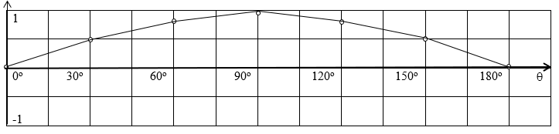
b. Given y = 3 - x + 2x² and x is increased from 4 by an amount r/100 where r is small, find in terms of r
i. the approximate change in y, (4 marks)

ii. the percentage change in y. (3 marks)

- a. Suppose Q = f(t) is an exponential function of t. If f (20) = 88.2 and f (23) = 91.4 and letting Q = Q₀a^{t},
- find the base (5 marks)

ii. find the growth rate. (2 marks)

b. Solve for x in |x - 3| ≤ 2 and sketch your solution on the real line. (6 marks)

- a. Use a table to estimate the limit of $\frac{x^{2}- 9}{x - 3}$ for x values approaching 3 from above. [Use at least seven values of x.] (5 marks)
x
$$\frac{x^{2}- 9}{x - 3}$$

b. Evaluate $\int_{0}^{\frac{π}{6}}{\cos^{3}}x dx$. (6 marks)

- A spherical balloon is being filled with air at the constant rate of 2 cm³/sec. How fast is the radius changing when the radius is 3 cm? (6 marks)

Section B (40 marks) (Solve any two problems in this section)
- a. Given the following equation 2x² - 3x - 3 = 0, by completing the square method.
calculate
i. the coordinates of the turning point (5 marks)

ii. the equation of the line of symmetry. (5 marks)

b. Figure 2 is a circle centre O with a radius of 4 cm. AB is a chord of length 4 cm and divides the circle into two segments.
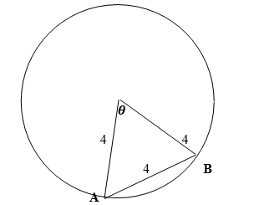
Figure 2
Calculate, correct to 2 decimal places, the area of the minor segment. (10 marks)

- a. Solve the following inequality 2x³ + 3x² ─ 8x + 3 ≥ 0 using the graphical method. [shade the region.] {Use the graph space on page 12.} (12 marks)

b. Differentiate f(x) = $\frac{1}{x}$ by first principles. (8 marks)

- a. Prove that (1 $-$ cosA) (1 + sec A) $≡$ sinA tanA. (9 marks)

b. Figure 3 shows two graphs of y₁ = x and y₂ = x² - x intersecting at A and B.
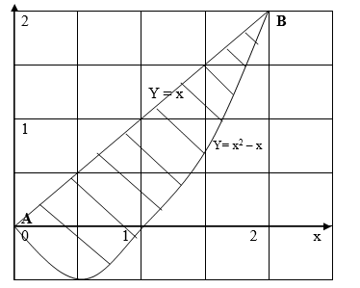
Calculate the area of the shaded part, giving your result to 1 decimal place. (11 marks)

END OF QUESTION PAPER

